

**Through collaboration of**

**and**

**2020 SPRING AGILE ANALYSIS VITRUAL STUDY GROUP**

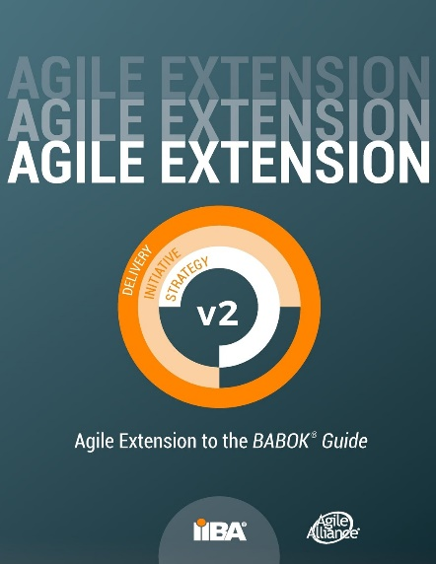

Are you interested in the IIBA® Agile Analysis (IIBA®-AAC) certification, or just would like to learn more the content of *Agile Extension to the BABOK*® *Guide version 2?* Then this agile business analysis training opportunity is for **you!**

Bluegrass IIBA Chapter will host a virtual Agile Analysis Study Group for those individuals interested in IIBA®-AAC certification or learning the *Agile Extension* *to the BABOK® Guide* to advance their career.

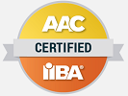

The study group will run for 5 sessions on Thursday evenings beginning on April 30, 2020. We ask students to begin studying early so it is a good idea to be registered at least one week prior to the first session. Students will be provided with course material, including an AAC Study Guide and study workbook.

This study group is an instructor-led course, and will be taught by Vice President of Professional Development, Aaron Whittenberger, CBAP, CSPO, AAC

Please note that this study group is open to everyone internationally. Please understand that this course is taught in **American English**.  Study sessions are at **6:00 p.m. EDT**. If you are not in the Eastern time zone of North America, you will need to translate this time to your time zone.

If you have any questions concerning this study group, please email Vice President of Professional Development, Aaron Whittenberger at [Professional@bluegrass.iiba.org](mailto:Professional@bluegrass.iiba.org).

Participation fees:

**Early Bird Pricing until April 11, 2020**

Bluegrass Member and Annual Pass. . $125

College Student . . . . . . . . . . . . . . . . . . $100

Guest Registration . . . . . . . . . . . . . . . $190

**Regular Registration**

Bluegrass Member and Annual Pass . .$165

College Student . . . . . . . . . . . . . . . . . . $135

Guest Registration . . . . . . . . . . . . . . . $240

*\* Volume discounts available for organizations that send 5 or more students.*

Schedule: 5 sessions

1. Thursday, April 30, 2020, 6:00 PM 8:30 PM (EDT)
2. Thursday, May 07, 2020, 6:00 PM 8:30 PM (EDT)
3. Thursday, May 14, 2020, 6:00 PM 8:30 PM (EDT)
4. Thursday, May 21, 2020, 6:00 PM 8:30 PM (EDT)
5. Thursday, May 28, 2020, 6:00 PM 8:30 PM (EDT)

*“Provides All the tools necessary to take you from study group to successful scholar, AAC certification” –prior participant*

For more information and to register: https://bluegrass.iiba.org/event-3689014